Chapter 3
Object Oriented Concept

- Introduction

An object is a unit of code that is responsible to accomplish a particular task located inside code. In other way, we can tell that an object is a data structure which solves a particular problem. To do its work, an object may need some data (i.e. fields) and methods.

In this chapter, we will learn ‘How to think in Object Oriented way’ and how to write Object Oriented code to solve our problem. Here, we will discuss Object Oriented Though process, attributes and responsibilities of an object, what object and class means. At the end, we will see the comparison between several designs of objects.

  - How to Start Object Oriented Programming?

Most of us started Object Oriented Programming (OOP) by jumping into a language book like Complete Reference of C++/Java/C# etc. So, from these books we might have learned how to use their classes (class library) or even learned how to write your own classes and making object from them. But OOP is more than these. Designing beautiful classes, keep them simple, make them for reusability and easy to change is the ultimate goal of OO code and design.

So, what should we know first? First of all we should know: what’s an object and how to think in Object Oriented way.

  - OOP Thought Process:

Starting of Object Oriented Programming is of course the concept of object i.e. what object means? This concept is really simple. Let’s talk about it. Before starting, I am requesting you to forget everything about programming, database design, software design i.e. all kinds of software engineering and programming language details for some couple of minutes (not forever!!).

    - Everything can be an object

Look around us, what we see? ALL ARE OBJECTS. We see computer, chair, table, pen, air cooler, carpet etc, all these are objects. Why these are objects? Pretty simple, they have some related attributes and some related activities.

Think about computer, it has processor, RAM, hard drive, keyboard, mouse, etc. All these are the attributes of a computer. Now, what’re the activities of a computer? It has a lot: it runs antivirus program, displays information, accepts requests and executes these properly. All these are the activities of a computer. So, computer is an object.

In the same way, we will get the attributes and activities of chair, table, etc. So, to be an object, something should have attributes and/or should have activities. Finally, we could say: Everything can be an object.

Is it possible that any event, like war or raining, singing, thinking etc. (which are not visible or tangible) can be an object? The answer is YES. These can be objects also. Think, raining has attributes: whether is it drizzling or “cats and dogs”? Singing can be an object if we consider, in which frequency-range it is sung?

‘Name’? – is it an attribute or an object? Actually, it depends on problem domain. if we think about a banking solution then customer ‘Name’ will be an attribute of customer. But if it is a business from where you can purchase the ‘Name’ of your new-born baby then ‘Name’ will be an object to this business. Because ‘Name’ has attributes: name of baby boy or girl?, meaning, type, etc.

Note: In some OOP books, authors may use data instead attribute and responsibility instead of activity.

    - Object’s data and responsibility depend on problem domain

If I tell you and your friend to find out the data and activity of customer object, suppose, you get customer with name, email, phone attributes and purchase, bargain activities. At the same time your friend may get customer with first name, middle name, last name, gender, credit card attributes and open account activity.

Why it happens? It happens because you and your friend were on different platform with different point of view. You have thought about the customer of a grocery store whereas your friend has worked with the customer of a bank. But both of you are right. So, object and its data, responsibility everything totally depends on problem domain.

    - What is class?

Class is the blue print of an object. Suppose, Nirob Hasan, Linda Suzana and James Scott are students. Here, Nirob Hasan, Linda Suzana and James Scott are objects and Student is the class. More specifically, Student is the class which has Regi no, Email and Name attributes and there are three student objects whose names are Nirob Hasan, Linda Suzana and James Scott. See the following figure and get an idea of class and object.

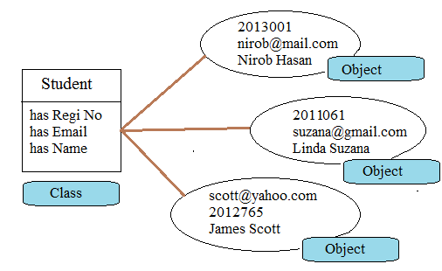

Fig: Object and Class

Walkthrough 1: Mapping Object Oriented Thoughts to Object Oriented Programming

So, we know what is class and what is object. So, let’s try a very simple example.
Our considering problem domain as follows:

“User wants a program where (s)he will enter first name, middle name and last name of a person, press a button, full name and reverse full name will be shown just below.”

We will identify the objects first. Here, we will get ‘Person’ object as follows:

Person
Has first name
Has middle name
Has last name

Can tell its full name
Can tell its reverse name

Now we will implement our above thought in C# by following steps:

Steps:

- Start Microsoft Visual Studio 2010

- Click File>New>Project

Select ‘Class Library’ template from the list of templates, give a meaningful name and select your preferable location where VS 2010 will create all the related folders and files.

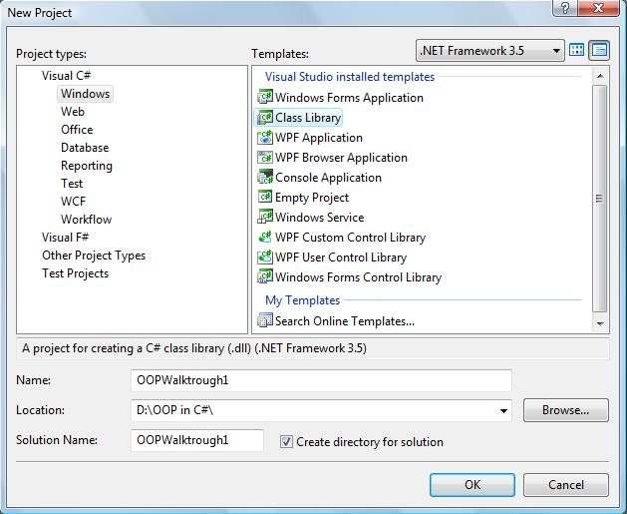

- Click ‘Ok’ Button

- In Solution Explorer, we will see Class1.cs file. Delete this file.

- Select project (not solution) OOPWalkThrough1 and click right button. Then select Class from the templates.

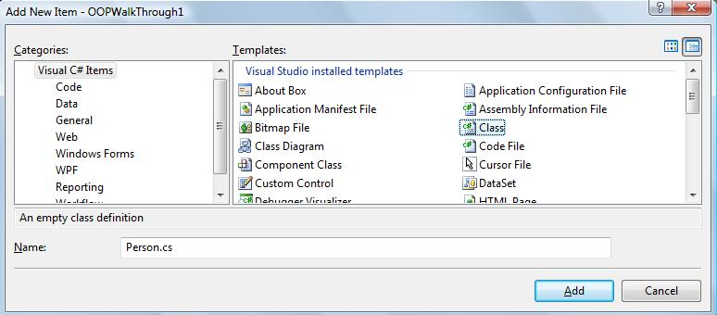

- We have found an object, ‘Person’ in our problem domain and now we are creating class for it. So, here we will give ‘Person.cs’ in Name as a file name.
- Click ‘Add’ button and we will see the following code

using System;

namespace OOPWalkThrough1
{
class Person
{
}
}

- Now update the Person class as follows:

namespace OOPWalkThrough1
{
class Person
{
public string firstName;
public string middleName;
public string lastName;

public string GetMyFullName()
{
return firstName + " " + middleName + " " + lastName;
}

public string GetMyReverseName()
{
string reverseName = "";
string fullName = GetMyFullName();
for (int index = fullName.Length - 1; index >= 0; index--)
{
reverseName += fullName[index];
}
return reverseName;
}
}
}

Have a look inside the Person class. Compare the identified object, Person with the Person class written above.

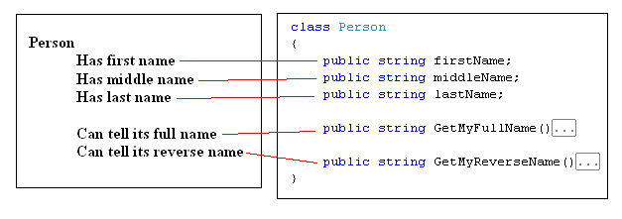

We see data of Person are represented by attributes and responsibilities are represented by methods. So any object creates from Person class will represent our domain object, Person.

- Now, add another class in this project. Here file name will be EntryPoint.cs (or any meaningful name you like) and write Main() method inside this class as follows:

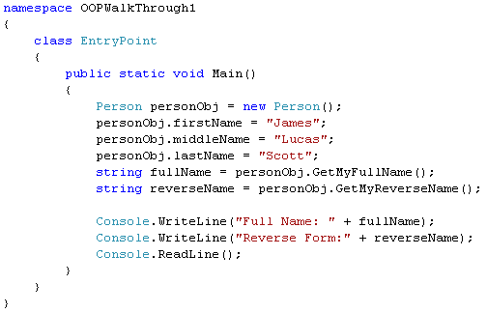

Here, we create a Person object, personObj from Person class using the following line:

Person personObj = new Person();

Then assign some data to the attributes of personObj as follows:

personObj.firstName = "James";
personObj.middleName = "Lucas";
personObj.lastName = "Scott";

Finally, call its two methods to get full name and reverse name from it:

string fullName = personObj.GetMyFullName();
string reverseName = personObj.GetMyReverseName();

We have started our project as a class library so if you run it you will get an error. Since the output of a class library is DLL it can’t be run.

- To make the project executable, we need to change the project properties. Select the project, click right button, select Properties from pop-up menu; we will get the following tab to change project properties.

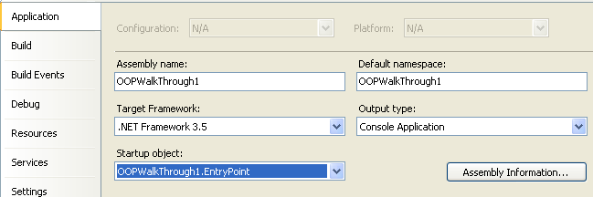

Select Output Type as Console Application and Startup object as OOPWalkThrough1.EntryPoint.

- Run the application and we will the output as follows:

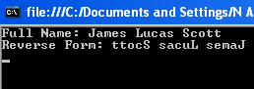

- Now we will update the code so that we can take input from user instead of hard-coded value. Replace these three lines

personObj.firstName = "James";
personObj.middleName = "Lucas";
personObj.lastName = "Scott";

with the following three lines

personObj.firstName = Console.ReadLine();
personObj.middleName = Console.ReadLine();
personObj.lastName = Console.ReadLine();

Now run the application and test it for several inputs. Find the code of this walkthrough in OOPWalkThrough1 inside WalkThroughs folder.

Let’s have look into the files and folder created in the selected folder for the above project.

Walkthrough 2: Convert the application of Walkthrough 1 to Windows application.

These walkthrough is based on Walkthrough 1. So, open the project of Walkthrough1 and do the following steps:

- Add a new Form class in your project (Right-click on project, click Add>Windows Form). In name textbox, type PersonInformationUI.cs and click Add button. Then you will see a windows form.

- Design the windows form as following UI and give the appropriate name of each control.

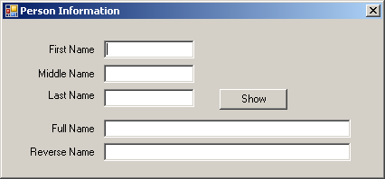

- Write the following code inside Show button_click event:

Person personObject = new Person();
personObject.firstName = firstNameTextBox.Text;
personObject.middleName = middleNameTextBox.Text;
personObject.lastName = lastNameTextBox.Text;

fullNameTextBox.Text = personObject.GetMyFullName();
reverseNameTextBox.Text = personObject.GetMyReverseName();

- Change your Main() method of EntryPoint class with following code:

PersonInformationUI personInformationUIObj =
new PersonInformationUI();
Application.Run(personInformationUIObj);

- Right-Click on project of solution explorer. You will see a popup and click properties. Select Application Tab, Change output type to Windows Application.

- Run the application and see it works.

By following the steps of two above walkthroughs, we have created a small desktop application by which user can get full name and reverse name giving first name, middle name and last name. First we have identified domain object, Person and then we have created class, Person using C# code without starting with Windows Form.

We have started with Class Library template instead of Console or Windows Form Application, because we have planned to write all the classes from scratch needed for this project. But it’s doesn’t mean that we should following this way for any desktop application.

Practice 1: Application for bank account transaction

User story:

“As a customer
I want to create an account and want to deposit and withdraw in my account.”

See the UI prototyping:

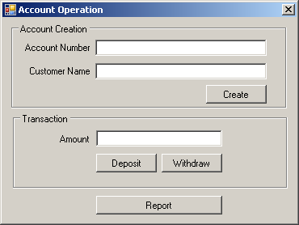

When report button is clicked, information will be displayed as follows:

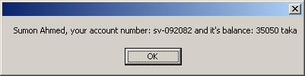

Hint: Do the brain-storming work first. Don’t start coding right now. Find out an object and write its name, attributes and responsibilities in pen and paper. Do these by discussing with your peer and after that start coding.

Now, see the solution in Solutions folder. Project name: BankAccountOperation and find the difference between your code and given code. Let’s discuss it.

Practice 2: Make a calculator as follow:

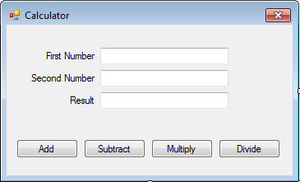

Hint: Remember, you should do the brain-storming work first. Don’t start coding right now. Find out an object and write its name, attributes and responsibilities in pen and paper. Do these by discussing with your peer and after that start coding.

Have a look into the given solution in Solutions folder. Project Name: CalculatorApp. Have you seen any difference? Let’s discuss these.

Practice 3: Make a salary calculator

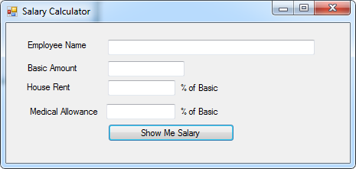

User will input data and click Show Me Salary button and then total aalary will be shown in a MessageBox, like: Sumon your salary is: 78500

Hint: Please do brain-storming work with your peer and do it before coding. There’s a solution in Solutions folder. Project name EmployeeSalaryApp. Compare your code with it.

Practice 4: Make a circle class by which user can get diameter, perimeter, and area of it providing the radius of it. Write Main() method inside Program class to demonstrate your work.

Comparison between alternative designs of objects:

Let’s start a discussion on two alternative designs of each object so far we have found.

  Person
  firstName: string
  middleName: string
  lastName: string
  GetFullName():string
  GetReverseName(): string
  Person
  GetFullName(fN: str, mN: str, lN:str):str
  GetReverseName(fN: str, mN: str, lN:str): string
  Calculator
  firstNumber: double
  secondNumber: double
  result: double
  Add():double
  Subtract(): double
  Multiply(): double
  Divide(): double
  Calculator
  Add(frN:double, sndN:double):double
  Subtract(frN:double, sndN:double):double
  Multiply(frN:double, sndN:double):double
  Divide(frN:double, sndN:double):double
  BankAccount
  number: string
  name: string
  balance: double
  Withdraw(amount: double):string
  Deposit(amount:double): string
  BankAccount
  Withdraw(no:str, name:str, blnc: dbl):string
  Deposit(no:str, name:str, blnc:dbl): string
  Circle
  radius: double
  GetArea():double
  GetPerimeter():double
  GetDiameter():double
  Circle
  GetArea(r:double):double
  GetPerimeter(r:double):double
  GetDiameter(r:double):double

Everything can’t be covered in a sample example or even in a big one:

Here, to keep the example simple, I’ve violated encapsulation (keep the data public) principle.

To solve a problem, mapping a domain object directly to software object sometimes may not be a good solution.

